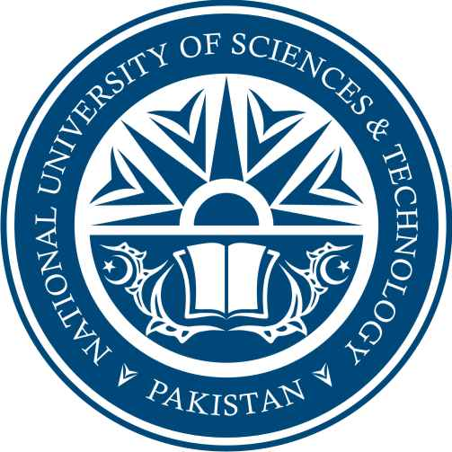
NUST School of Electrical Engineering and Computer Sciences
A center of excellence for quality education and research

CERTIFICATE

Certified that the Scrutinizing Committee has reviewed the final documentation of Mr./Mrs/Miss._Umair Anwar_______________Regno__2011-NUST-MS Phd-IT-049__
Student of MSIT thesis title_Automating Exchange of Educational Certificates Using DRESS_ and found satisfactory as per NUST’s standard format for Master Thesis.

President
Mr. Muhammad Ramzan

